UHSDR Bootloader Installation Procedure
for First Time Install Bootloader or Upgrading Bootloaders
– The P6-Jumper Method –

This document describes a bootloader (and firmware) installation/upgrade procedure, which works both on new machines with a fresh STM32 cpu (which do not have an bootloader) and also machines which already have bootloader and firmware installed. It is suitable for mcHF 0.4 – 0.6, OVI40, and mcHF 0.7. For other UHSDR TRX essentially you can follow the procedure, although pin numbers for power supply may differ.
It requires the closing a specific jumper named P6 on the UI board (mcHF 0.7: P206 on LOGIC board), hence the name P6-Jumper method. Current UHSDR bootloaders (once installed) provide firmware and bootloader update capabilities which do not require the use of jumper P6. Because of this in most cases you only have to follow these instructions once.
There are alternate procedures possible for bootloader and firmware installation/upgrade. Most require a UHSDR bootloader or special hardware (ST-Link). The method in this document only needs a PC running Windows or Linux (possible also MacOS X, not tested), some freely available software and a working UI board.

Prerequisites

- It is recommended use just the UI board and a stable 5V supply. However, you may use the fully assembled set of boards (RF+UI for OVI40, mcHF 0.4 – 0.6; RF+LOGIC+UI for mcHF 0.7) to supply the power but this more dangerous, since you have to keep the power button pressed all the time. If you stop pressing the power button during update, you may brick the UHSDR TRX and it can be recovered using the debug interface and a ST-Link debug device only. YOU HAVE BEEN WARNED!
- Get a bootloader (dfu extension). There are two different bootloaders available:
  - UHSDR bootloader (you can do firmware updates without PC using a simple USB key). You can get this bootloader from GitHub page https://df8oe.github.io/UHSDR/. This bootloader is available for STM32F4 based TRX (mcHF 0.4 – mcHF 0.7, name bl-mchf.dfu), and STM32F7 based TRX (OVI40, bl-40SDR.dfu).
  - M0NKA bootloader (you have to use close source mchf-manager and PC for fw-upgrade, bootloader does not support „reboot function“ of firmware). The M0NKA bootloader is availble at http://www.m0nka.co.uk/?page_id=5269 . This bootloader works only with STM32F4 devices. Use of this bootloader is not recommended, but possible.
- Windows: Download and install DfuSETools from ST: http://www.st.com/en/development-tools/stsw-stm32080.html
Linux: Install the dfu-util package using your favorite package manager.

Common Procedure
First steps are identical for Windows and Linux:
- Connect USB-cable with mini USB plug on the other side of cable.
- Close P6 jumper at the bottom of the UI board / mcHF 0.7: P206 on LOGIC board
- Only for STM32F4 (mcHF 0.4 – 0.7) Press and hold BAND+ button (not required on UHSDR TRX using an STM32F7xx/STM32H7xx MCU, such as the OVI40)
- Connect 5V to pin28 of UI board header/ mcHF 0.7: Pin 12 at connector P1c or Pin 6 on connector P1b. You will get a white screen now – that‘s ok!
- Connect USB plug from PC to small USB connector
- Release BAND+ if a new device is recognized

Windows Procedure
- Complete all steps in „Common Procedure“
- Let Windows finish driver installation procedure
- Start the DfuSeDemo application.
- Now run the procedure shown beside the image. Please follow all steps exactly as described.
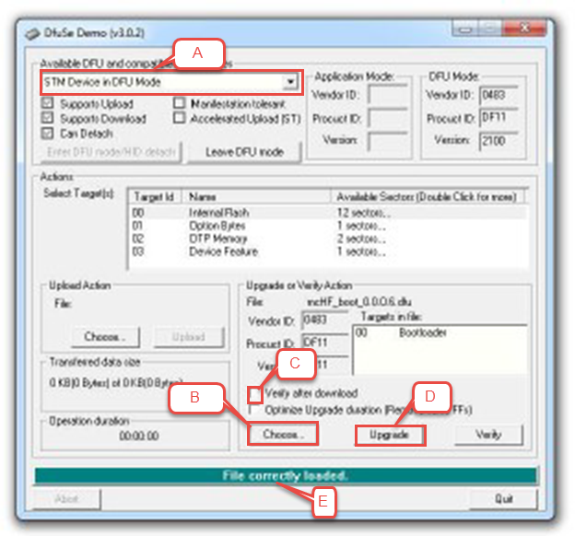
1. If you can see (A) „STM Device in DFU Mode“ in the left upper box connection between STM MCU and program is working.

2. Now press (B) „Choose...“ located in the right down area and select the downloaded bootloader file with extension „.dfu“.

3. Set a mark to (C) „Verify after download“ in the same area.

4. Press (D) „Upgrade“ in the same area. It will take a few seconds and then process hopefully is finished successfully.
5. Now disconnect power from UI board and remove jumper P6 if used.

6. You are ready to install the firmware now!

Windows FAQ
Q: I followed all steps exactly as described but I still see the old firmware/bootloader version (or the white screen if first time install).
A: In 99.99% percent of the cases, you did not follow the instructions exactly. The problem is, even if you followed the instructions finally exactly, you may have overwritten the firmware or bootloader dfu file with the flash contents downloaded from the device. Flashing this back to the device naturally creates no visible change. If in doubt, download the dfu file again, and follow the instructions exactly cures the problem. Just for the record: We all once pressed „Upload“ instead of „Upgrade“ and were wondering why nothing happens.

Linux Procedure
- Complete all steps in „Common Procedure“. Remember to use the appropriate bootloader file.
- Run dfu-util -d -R -a 0 0483:df11 -D /this/is/path/to/bl-for-my-device.dfu

You can use the same command with a firmware DFU file (just replace filename).

V2.1, DF8OE/DB4PLE

